**PROPOSAL**

**Automated Classification of Skin**

**Lesions using Machine Learning and Deep Learning Methods**

**Student Name**

**Student ID**

**Abstract**

Skin cancer is one of the most widely occurring disease, globally. Early stage and precise diagnosis of Skin disease prevent its severe outcomes and assist doctors in efficient treatment. Diagnosis of this disease is considered to be a time consuming and costly process. Induldging machine learning based solutions could assist medical practitioners in overcoming these issues. Therefore, in our study, we have presented an efficient transfer learning based approach for the automated multi-class classification of skin cancer in three categories I.e., benign, malign and keratosis. The performance of this approach has also compared with two machine learning based models and Convolution Neural Network. However the transfer learning based approach has outperformed all other approaches.

1. **Introduction**

Skin cancer is considered to be one of the most widely occurring and fatal category of cancer [5]. In general it is primarily caused by the exposure of skin to the ultraviolet rays came from the sun. These rays are hazardous f or the skin cells DNA. The risk of this fatal disease gets further elevated, when the skin gets exposure with specific light sources I.e., sun lamps and tanning beds [2]. The occurrence of this disease could be gauged by the statistic I.e., an estimated amount of 99,780 young women and men belongs to USA gets diagnosed with skin melanoma in 2022 [3]. In addition to this, according to a global statistic in 2020 an estimated amount of 324,635 individuals are diagnosed with this disease [4].

Skin cancer or skin lesions is concerned with the dominance of abnormal skin patch over the body. These lesions could be categorized into two types: I.e., 1) primary and 2) secondary lesions. In primary type of lesions, the abnormalities gets evolve with time, such lesions could also exists from birth. The secondary category of skin lesions are baiscaly develop by the alteration of primary lesions. After the scraping and bleeding of mole the developed crust is a primary cause of secondary lesion [5]. For dealing up with these abnormalities: the doctors normally refers either home care, medicinal treatment or surgery. One of the most dangerous type of skin abnormality is considered to be Melanoma, whose timely and precise diagnosis is considered to be crucial [6].

For automating the cancer analysis and diagnosis task, machine learning and deep learning based methods could be employed that would aid in enhancement of clinical reliability, in reduction of human errors, in assistance of physicians, in reduction of medicinal cost and also in easy and precise disease diagnosis.

In this study, we have employed three different approaches including: machine learning, deep learning an transfer learning, for the classification of skin lesions in three classes I.e., 1) benign, 2) malign and 3) seborrheic keratosis class. To perform this task, we have utilized ISIC challenge 2017 dataset [7], which is primarily partitioned into three categories i.e., training, validation and testing dataset. The training dataset incorporate 2000 lesion images and 2000 super-pixel images, from which we have utilized lesion images. From testing dataset 600 lesion images, while from validation dataset 150 lesion images have been utilized fo the evaluation of proposed model. The primary motive of our study is to elaborate the power of transfer learning pre-trained models.

1. **Research Objective**

The main objective of the above research is to generate an automated system for the classification of skin lesions using machine learning and deep learning methods. Specifically, this research aims to:

* Develop and compare conventional machine learning and deep learning models for the categorization of skin lesions into three types: melanoma, benign, and seborrheic keratosis.
* Assess the comduction of the developed models by the use of standard evaluation metrics for example accuracy and precision, recall and F1-score.
* Investigate the interpretability of the developed models and provide insights into the features that contribute to the classification of skin lesions.

1. **Literature Analysis**

Many of the authors in literature have considered upon the automated detection and classification of skin lesions by employing different machine learning and deep learning based methods, while evaluated these approaches over different datasets. Some of these studies have been mentioned below.

In [5], author has employed two machine learning based classifiers namely decision tree and random forest for the classification of skin lesions. Two different datasets have been utilized for the training of these models,while for the preservation of spatial information of input images high resolution feature maps have been extracted from them.

In [8], a set of handcrafted features have been extracted from input dataset for the classification of images, which includes: 1) Local Binary Pattern (LBP), 2) GLCM and 3) RGB color space. Before features extraction process, the region of interest has been extracted using fuzzy-c clustering method from which mentioned features have been extracted and fed to the machine learning classifier for skin lesions classification.

Keeping in view the significance of lesions boundary dominance, author in [9] has presented a conditional random field based encoder-decoder approach that refines the contours and localize the boundary of lesions using Gaussian kernel. For classification of lesion a fully convolution network have been utilized that give significant results.

For coping up with the issue of class imbalance in skin lesions dataset, author in [10] has presented utilization of different data augmentation techniques. The long-short-term-memory (LSTM) and a transfer learning based MobileNet V2 models has been employed over the processed dataset for the skin disease classification. The proposed approach has slightly increased the computational cost, however give improved results.

A hybrid of machine learning and deep learning based approach have been presented in [11]. The proposed algorithm is inspired from divide and conquer strategy known as Multi-Class Multilevel classificaation method. In [12], a transfer learning based methodology have been introduced for skin lesions classification. A well-known pre-trained Alex-Net model have been utilized as a base model, while three new layers have been added to it. The newly added layers gets fine-tuned over ISIC 2018 dataset.

Another hand-crafted features based machine learning approach have been presented in [13]. Author of the study has employed SVM classifier with RBF kernel for the categorization of three types of lesions. A set of handcrafted features extracted from input dataset has been fed to the mentioned model for training. These features include: color and texture features, fractal dimension, LBP and fractal-based regional texture analysis (FRTA).

1. **Methodology**

The main motive of this study is to design an automated approach for the classification of skin lesions into three primary classes. To do so, we have conducted this study in three stages I.e.,

1. In stage 1: the performance of machine learning based classifiers have been gauged for skin lesions classification.
2. In stage 2: the performance of deep learning based CNN classifier have been assessed for skin lesions classification.
3. In stage 3: the performance of transfer learning based approach have been evaluated for skin lesions classification.

The detailed description of designed methodology have been described in following sections.

* 1. **Dataset**

Dataset that we will use is the International Skin Imaging Collaboration (ISIC) Archive, which is a public repository of dermoscopic images of skin lesions [d]. We will use the ISIC 2017 challenge dataset, which contains a sum of 2,000 images(dermoscopic) of skin lesions, including melanoma, benign, and seborrheic keratosis. The dataset is balanced, with 33% of images belonging to each class.

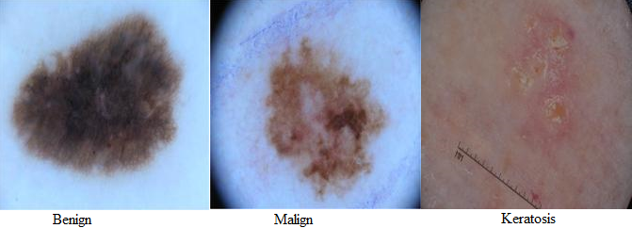

Figure 1: Sample Input Images

* 1. **Dataset Pre-processing**

Before feeding the dataset to any machine learning or deep learning based model, it is crucial to make it first compatible for the model. As in our study, we are utilizing ResNet-50 model, which takes image of size 224*224*3, therefore we have resized our input dataset to the mentioned shape in preprocessing stage.

* 1. **Model Training**

Three different categories of models have been employed and assessed in our study. The training of these datasets have been done differently over the training dataset. The details of their training process is given below:

* + 1. **Training of Machine Learning Classifiers**

Two different machine learning classifiers have been utilized in our study, such that Random Forest and SVM. For training of these classifiers we have extracted different handcrafted features from input images, which are:

|  |  |
| --- | --- |
| Feature | **Definition** |
| min | In min feature, we have extracted the minimum pixel value in each channel of input image. |
| median | In min feature, we have extracted the maximum pixel value in each channel of input image. |
| std | In std feature, we have extracted the standard deviation of pixel values in each channel of input image. |
| Min frequncy | To find this feature, we have calculated the histogram for each channel of input image and selected the pixel value with least occurrences. |
| Max frequency | To find this feature, we have calculated the histogram for each channel of input image and selected the pixel value with highest occurrences. |

A total of 15 features have been extracted i.e., 5 types of features for all 3 channels, These features are fed into the two selected models for training.

* + 1. **Training of Deep Learning Classifiers**

In deep learning based appraoch, we have designed a 14 layered CNN containing: 1 input layer, 3 convolution layers, 3 pooling layers, 4 dropout layers 1 Flatten layer and 2 Fully Connected layers. The training of this designed model has been done from scratch over training dataset with following hyper-parameters.

|  |  |
| --- | --- |
| **Hyper-Parameter** | **Value** |
| epochs | 50 |
| Batch size | 50 |
| Loss | Categorical Cross Entropy |
| Optimizer | ADAM |
| Regularization | DropOut at rate 0.2 |

* + 1. **Training of Transfer Learning Classifiers**

In transfer learning based approach, we have utilized ResNet-50 as the base model. The last classification layer has been removed for its training. The convolution part or features extraction part has been freezed, while 4 extra layers have been added to the model including 1 Flatten layer and 3 fully connected layers. The convolution part or freezed part of model has been used as features extractor while the newly added layers have been trained over the input training dataset. The training of this modified model has been doneover training dataset with following hyper-parameters.

|  |  |
| --- | --- |
| **Hyper-Parameter** | **Value** |
| epochs | 50 |
| Batch size | 50 |
| Loss | Categorical Cross Entropy |
| Optimizer | ADAM |

* 1. **Results**

In first phase, results evaluation of machine learning classifiers have been done. From the two machine learning classifiers i.e., random forest and SVM, SVM has depicted better results, such that a testing accuracy of 63.5% has been achieved by Random Forest, while a testing accuracy of 65.5% has been achieved by SVM classifier.

In second phase the results assessment of designed CNN has been done. The recorded training and validation accuracy and loss graphs have been depicted in Figure below.The graph clearly depicts that the model as undergo through over-fitting.

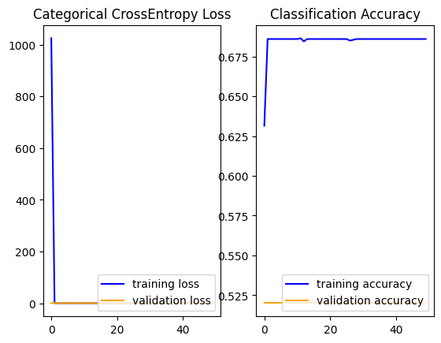

Figure 2: Training and Validation Accuracy and Loss Graphs of CNN

The predictions of the trained CNN along with the input images have been depicted in figure below. Blue captions depict correct prediction, while red is incorrect.

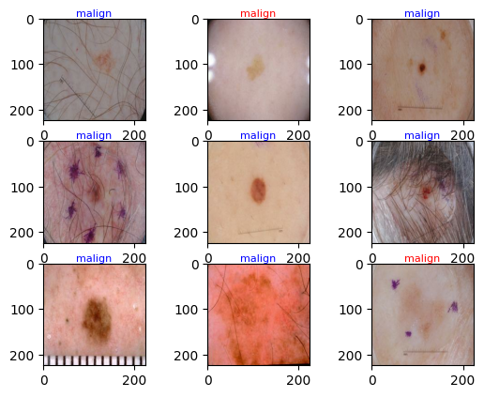

Figure 3: Predicions of CNN (red is incorrect, blue is correct)

The CNN model has achieved a validation accuracy of 51.9%, while a testing accuracy of 65.5% over validation and testing data respectively.

In third phase the results of transfer learning based ResNet-50 model has been done. The recorded training and validation accuracy and loss graphs have been depicted in Figure below.The graph clearly depicts that this model has also undergo through over-fitting but less severe then CNN.

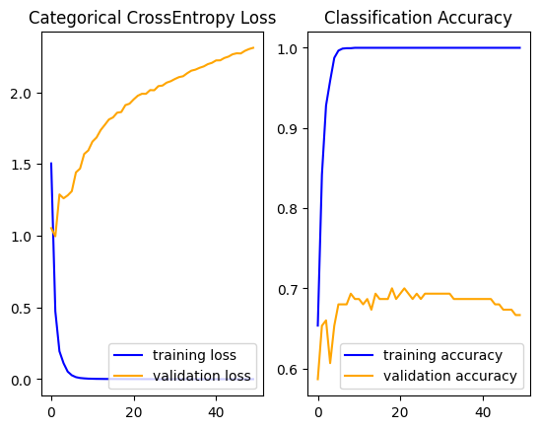

Figure 4 Training and Validation Accuracy and Loss Graphs of ResNet-50

The predictions of the fine-tuned ResNet-50 model along with the input images have been depicted in figure below. Blue captions depict correct prediction, while red is incorrect.

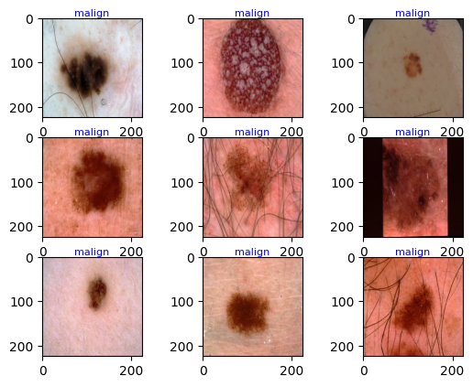

Figure 5: Predictions of ResNet-50 (red is incorrect, blue is correct)

The ResNet-50 model has achieved a validation accuracy of 66.67%, while a testing accuracy of 70.17% over validation and testing data respectively.

The table mentioned below depicts the accuracy comparison of all three utilized approaches over testing dataset. The results clearly depict that Transfer learning approach has performed best.

|  |  |  |
| --- | --- | --- |
| **Approach** | **Model Name** | **Accuracy** |
| **Machine Learning** | SVM | 65.5 |
| Random Forest | 63.5 |
| **Deep Learning** | CNN | 65.5 |
| **Transfer Learning** | ResNet-50 | 70.17 |

Performance Comparison on Testing Data Validation

1. **Conclusion**

Early stage and precise diagnosis of Skin disease prevent its severe outcomes and assist doctors in efficient treatment. In this study, we have presented a comprehensive comparison of three AI based automated approaches for skin cancer diagnosis. The training and evaluation of these approaches have been done over ISIC-2017 challenge dataset. Results shows that transfer learning based Res-Net-50 model has outperformed CNN, SVM and Random Forest Classifiers. A major downfall in accuracies of these models have been seen due to the highly imbalance nature of dataset.

1. **References**
2. C. Karimkhani et al. ”The global burden of melanoma: results from the Global Burden of Disease Study 2015”. In: British Journal of Dermatology 177.1 (2017), pp. 134–140.
3. D. L. Narayanan,R. N. Saladi, and J. L. Fox. ”Ultraviolet radiation and skin cancer”. In: International journal of dermatology 49.9 (2010), pp. 978–986.
4. ”American cancer society. Cancer Facts & Figures 2022”. In: Atlanta: American Cancer Society (2022).
5. W. H. Organization et al. ”International agency for research on cancer”. In: (2022).
6. Dhivyaa, C. R. et al. Skin lesion classification using decision trees and random forest algorithms. J. Ambient Intell. Hum. Comput.https://doi.org/10.1007/s12652-020-02675-8 (2020).
7. Abbas, S. et al. BCD-WERT: A novel approach for breast cancer detection using whale optimization based efficient features and extremely randomized tree algorithm. PeerJ Comput. Sci. 7, e390. https://doi.org/10.7717/peerj-cs.390 (2021) (PMID: 33817036; PMCID: PMC7959601).
8. Codella N, Gutman D, Celebi ME, Helba B, Marchetti MA, Dusza S, Kalloo A, Liopyris K, Mishra N, Kittler H, Halpern A. "Skin Lesion Analysis Toward Melanoma Detection: A Challenge at the 2017 International Symposium on Biomedical Imaging (ISBI), Hosted by the International Skin Imaging Collaboration (ISIC)". arXiv: 1710.05006 [cs.CV]
9. Kumar, M. et al. A de-ann inspired skin cancer detection approach using fuzzy c-means clustering. Mob. Netw. Appl. 25, 1319–1329 (2020).
10. Adegun, A. & Viriri, S. FCN-based DenseNet framework for automated detection and classification of skin lesions in dermoscopy images. IEEE Access 8, 150377–150396 (2020).
11. Srinivasu, P. N. et al. Classification of skin disease using deep learning neural networks with MobileNet V2 and LSTM. Sensors 21(8), 2852 (2021).
12. Hameed, N., Shabut, A. M., Ghosh, M. K. & Hossain, M. A. Multi-class multi-level classification algorithm for skin lesions classification using machine learning techniques. Expert Syst. Appl. 141, 112961 (2020).
13. Hosny, K. M., Kassem, M. A. & Foaud, M. M. Classification of skin lesions into seven classes using transfer learning with AlexNet. J. Digit. Imaging 33, 1325–1334 (2020).
14. Chatterjee, S., Dey, D. & Munshi, S. Integration of morphological preprocessing and fractal-based feature extraction with recursive feature elimination for skin lesion types classification. Comput. Methods Progr. Biomed. 178, 201–218 (2019).